**Jeremy Rios-Martinez**

**COMSC 265**

**Lab 10-11**

**Exersise 1: 1st run**

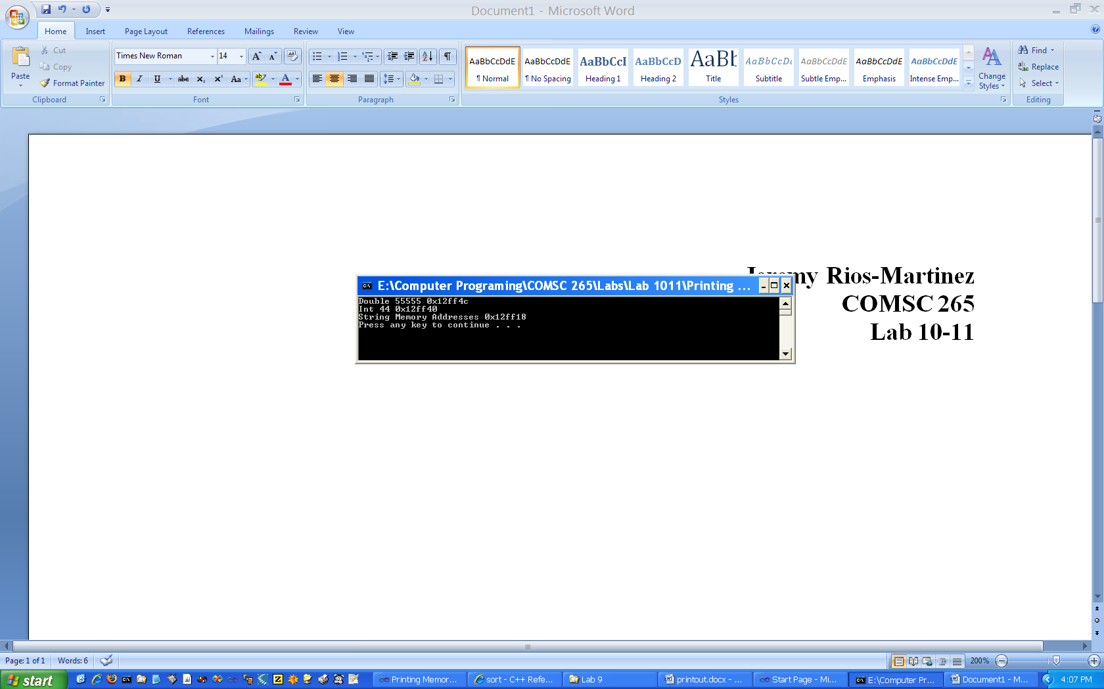

Questions

1. 2 hex characters ( = 256 : 00 = 0, ff = 255)

2. including the 0x, 4 bytes

3. varibles are located in the 1st half of the set of all memory locations

4. drawing....

**Exersise 1: 2nd run (after rearanging declarations)**

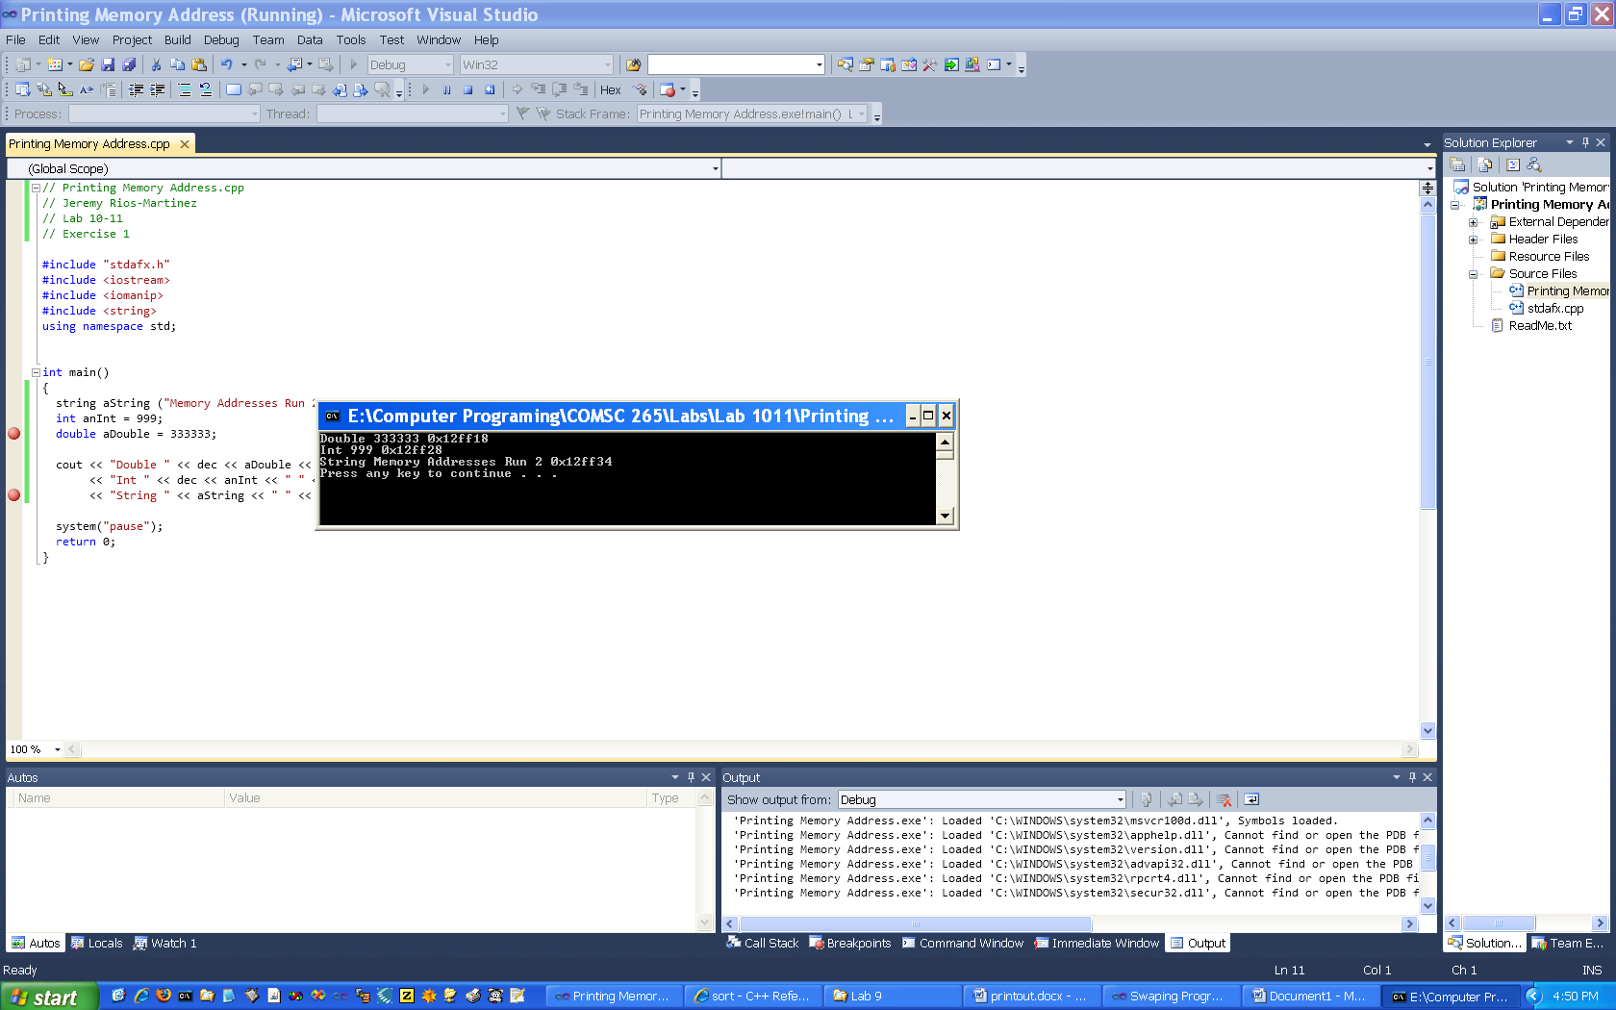

**Exersise 2**

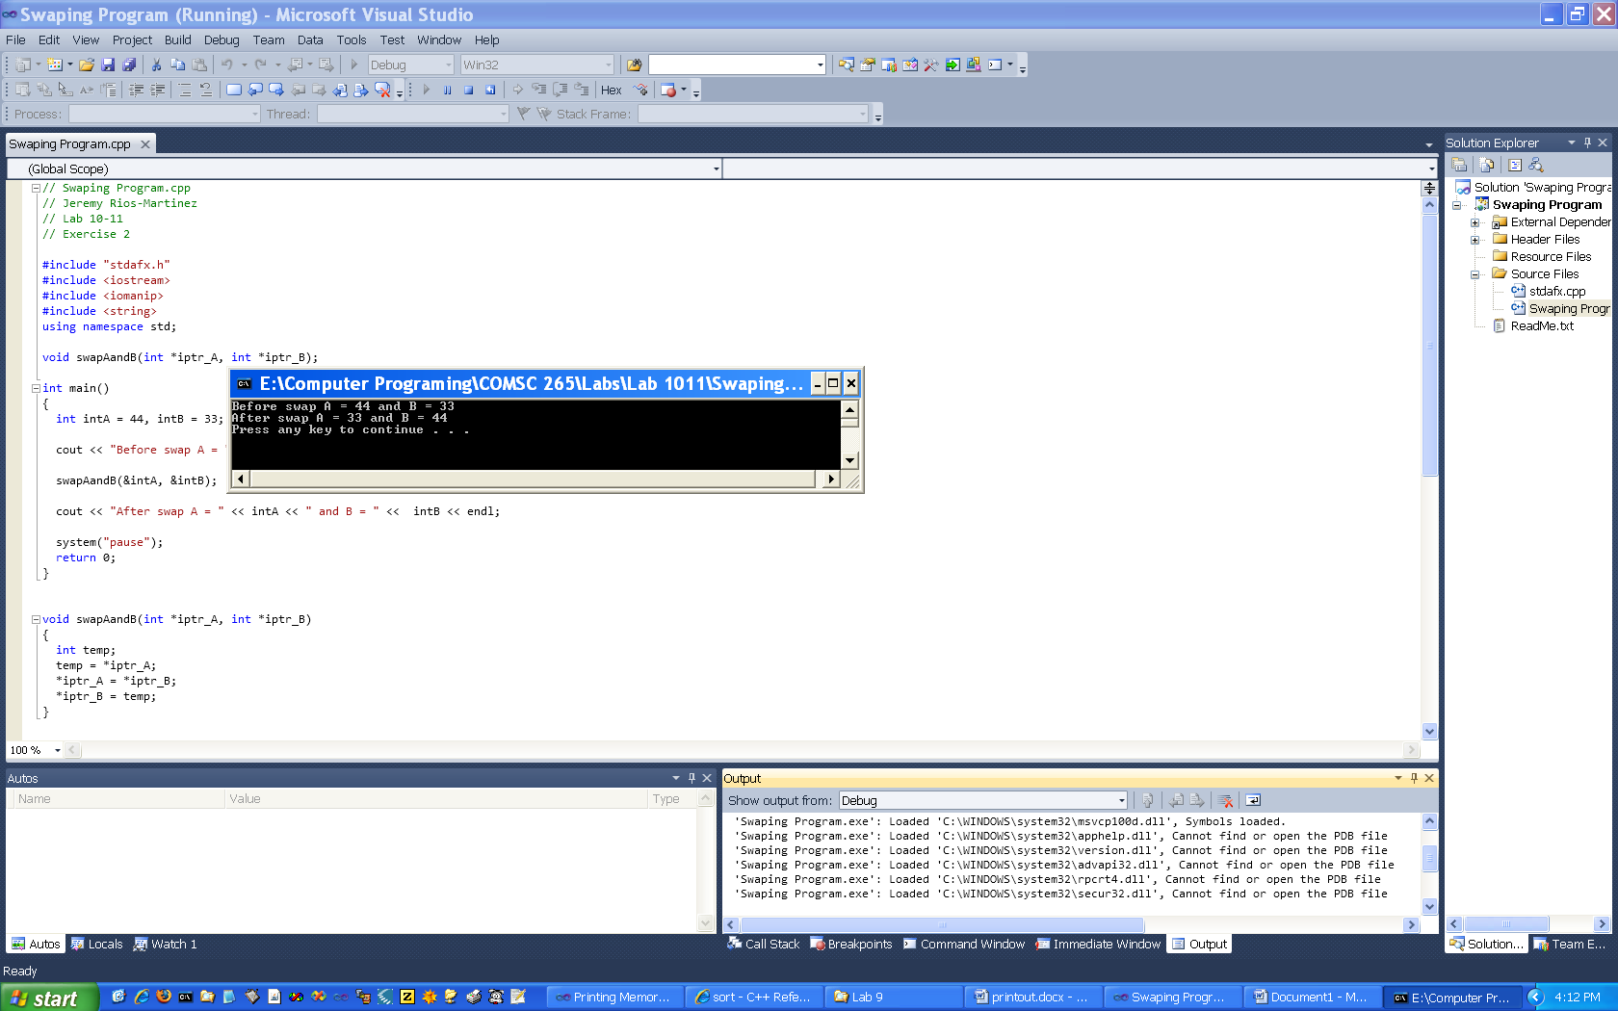

**Exersise 3**

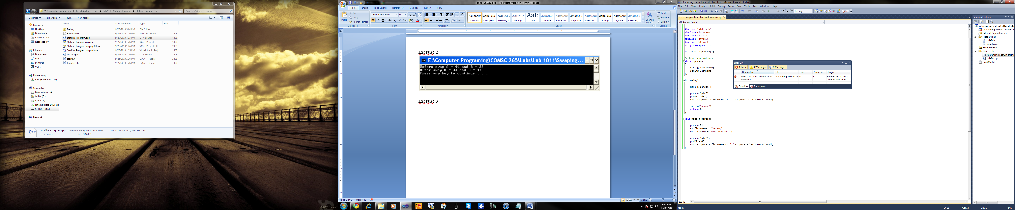

**Program will not compile because ptrP1 is attempting to reference P1which is out of scope**

**This is not good because it is pointless to try to reference an address to a struct or any other variable beyond the realm of its respective lifetime.**

**Exersise 4**

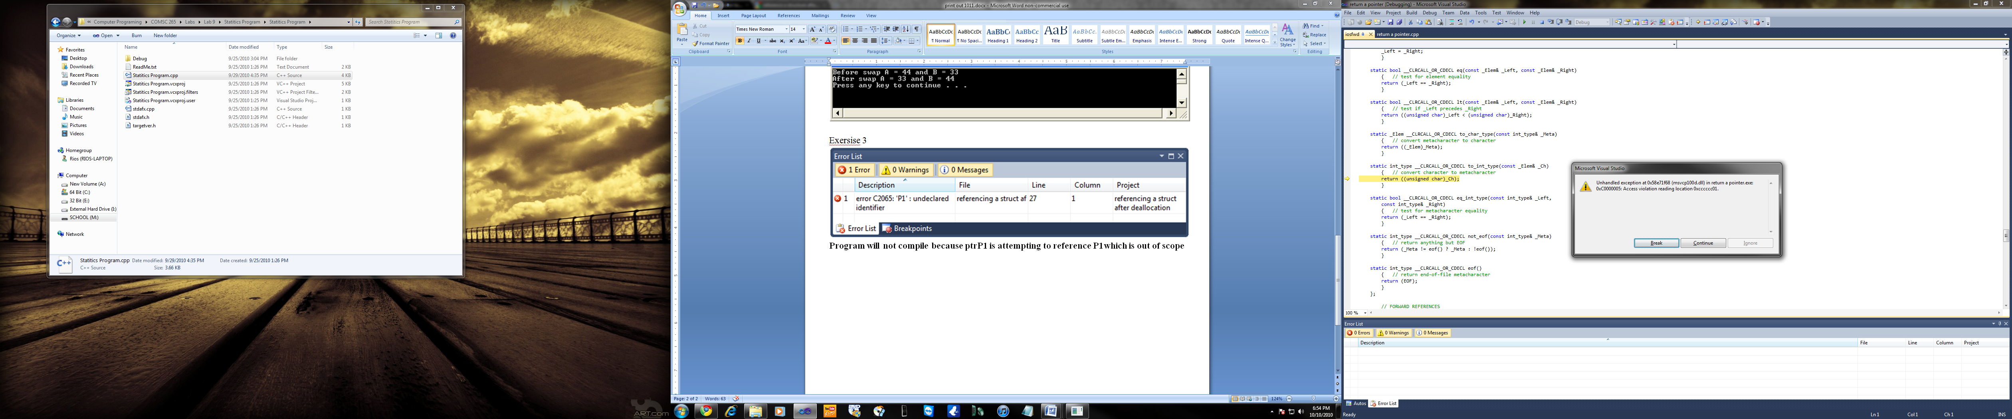

**Program immediately crashes because the function is attempting to return the address to P1which again is out of scope. This is not good because again, it is pointless to return an address to a struct or any other variable beyond the realm of its respective lifetime.**

**Exersise 5**

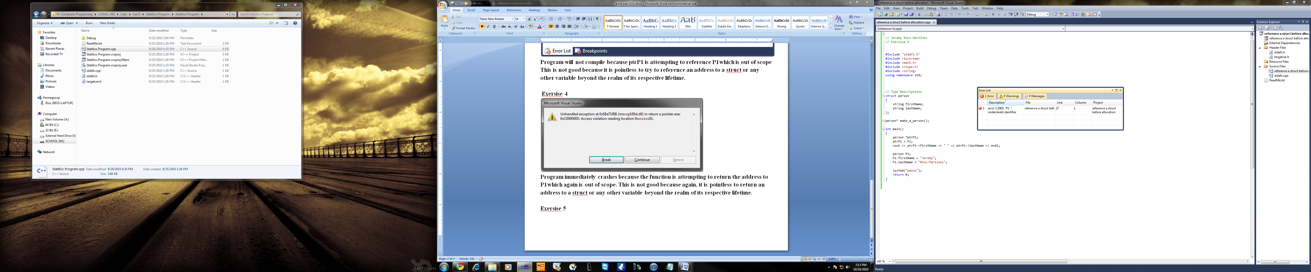

**Program will not compile because ptrP1 is attempting to reference P1which is does not exist. This is also pointless, because you are trying to reference variables that do not exist.**

**Exercise 6**

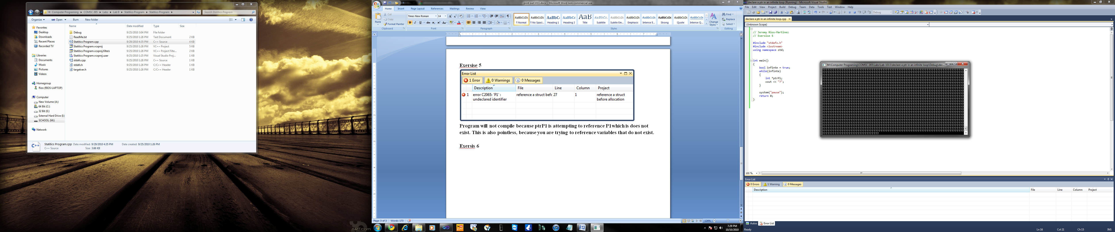

**The program repeatedly allocates memory for the pointer variable ptrP. This is defiantly not good. If the program was left running for a long time it may allocate all free memory in the system it is running on.**

* **Note – the system I was executing this program on, has a vast amount of memory so It will not issue a memory fault.**